Application Form to Adopt a Pony from Dial Wood Carriage Driving for the Disabled
Please fill in your details below:
Name: ______________________________________________________________
Address: ______________________________________________________________
______________________________________________________________
Postcode: ______________________________________________________________
Contact number: ________________________________________________________
Email address: ________________________________________________________
Date of Birth: ______________________

If your adoption is for a family member or friend as a gift, please fill in their details below:

Name: ______________________________________________________________
Address: ______________________________________________________________
______________________________________________________________
Postcode: ______________________________________________________________
Contact number: ________________________________________________________
Email address: ________________________________________________________
Date of Birth: ______________________

If you have any special requests, for example: Adoption Pack sending for a birthday – please advise below and we will try to accommodate. _______________________________________________________________________________________________

Which pony would you like to adopt?
Tyson Duncan Tonto Ellie
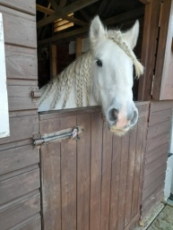

What’s next?
We will ensure that your application is processed as soon as possible so that you receive your Adoption Pack.
Please send your form, along with either a cheque made payable for £19.99 to Dial Wood Carriage Driving or proof of payment by bank transfer to 30-99-01 01786514
Return address: Adopt a Pony, Dial Wood Carriage Driving for the Disabled c/o 29 New Hall Way, Dial Wood, Flockton, Wakefield. WF4 4AX or email dialwoodcarriagedriving@gmail.com

